Experiment 9

Transient RL and RC circuit

Date: 2022/11/30

Class: 電機二全英班

Group: Group 4

Group member:

B103105006 胡庭翊

B103015006 劉姵妤

* + 1. With the resistor of 1kΩ and the capacitor of 100 $μF$, we know the time constants $τ=RC=0.1(s)$.

After 5 time constants, the circuit reaches steady state, that is, when the Vpp of function generator is given by 5V, after 5, the voltage will reach to almost 5V.

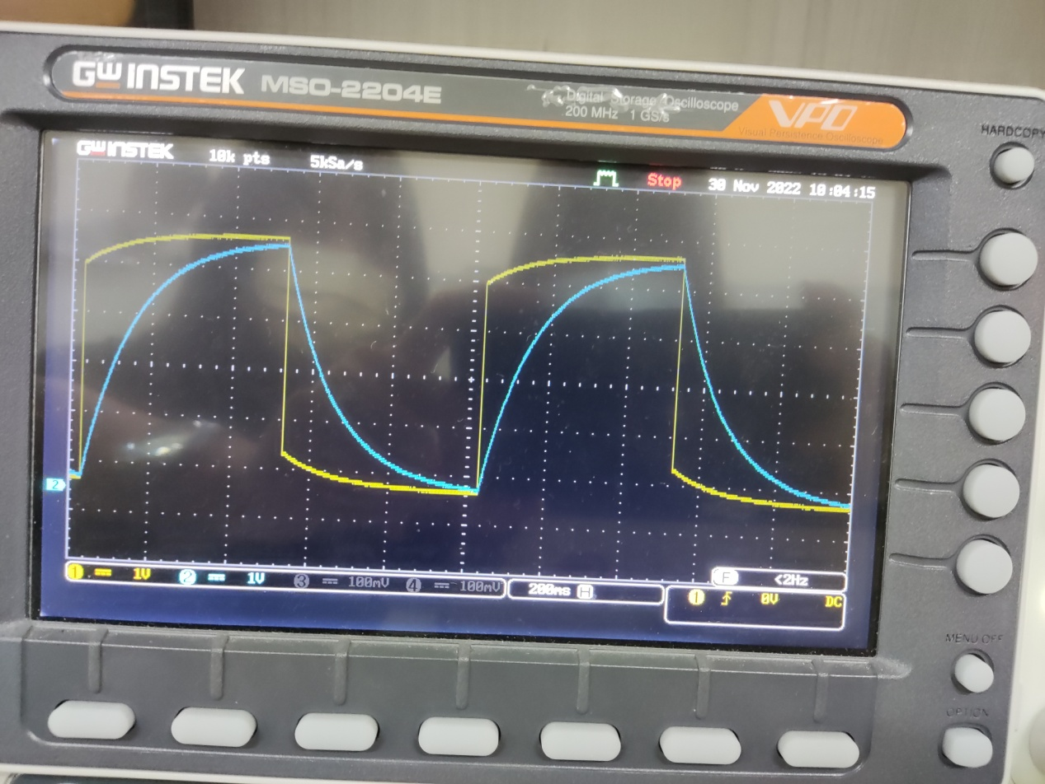

The output signal of channel 2 is the voltage curve of capacitor, and the output signal of channel 1 is the voltage curve of the whole circuit. According to the result of channel 2, after 500 (ms), the voltage change of capacitor reaches to steady state, 0.5 $÷5=0.1\left(s\right)$ would be the time constants, which is as same as the ideal.

* + 1. Yes, the time constants obtained during charging and discharging.
    2. With 2 resistors of 1kΩ connected parallel (equivalently 500Ω) and a capacitor of 100 $μF$ connected in series, we know the time constants $τ=RC=0.05(s)$.

After 5 time constants, the circuit reaches steady state, that is, when the Vpp of function generator is given by 5V, after 5, the voltage will reach to almost 5V.

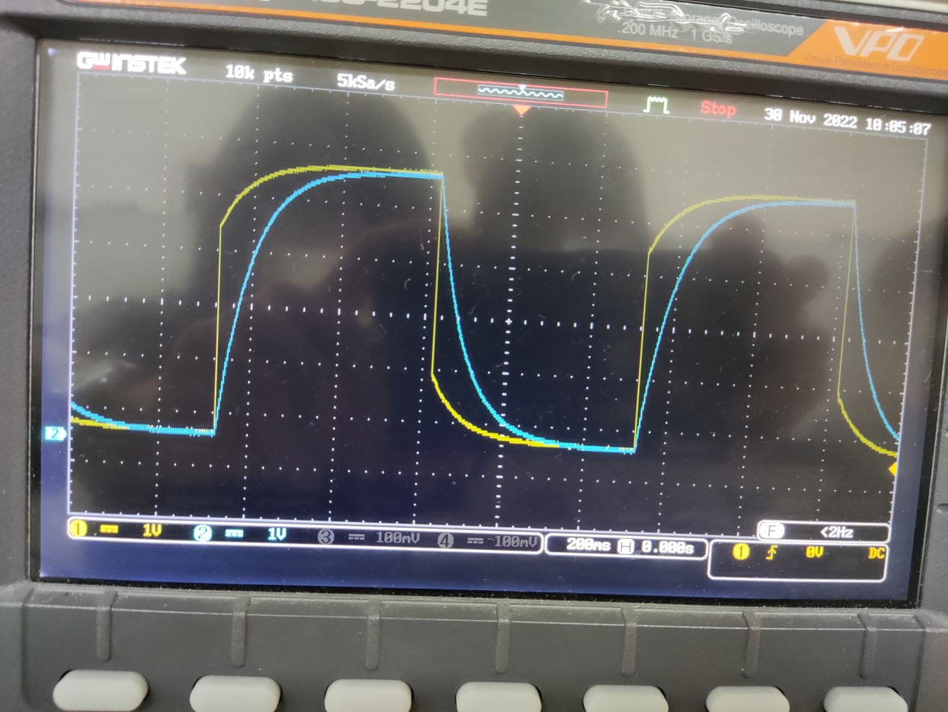

The output signal of channel 2 is the voltage curve of capacitor, and the output signal of channel 1 is the voltage curve of the whole circuit. According to the result of channel 2, after 250ms, the voltage reaches to steady state, 0.25 $÷5=0.05\left(s\right)$ would be the time constants, which is as same as the ideal.

* + 1. Yes, the time constants obtained during charging and discharging.
    2. With a resistor of 50Ω and a inductor of 10 $mH$, we know the time constants $τ=L/R=0.0002(s)$.

After 5 time constants, the circuit reaches steady state, that is, when the Vpp of function generator is given by 1V, after 5 $τ$, the voltage will decreased to almost 0.01V.

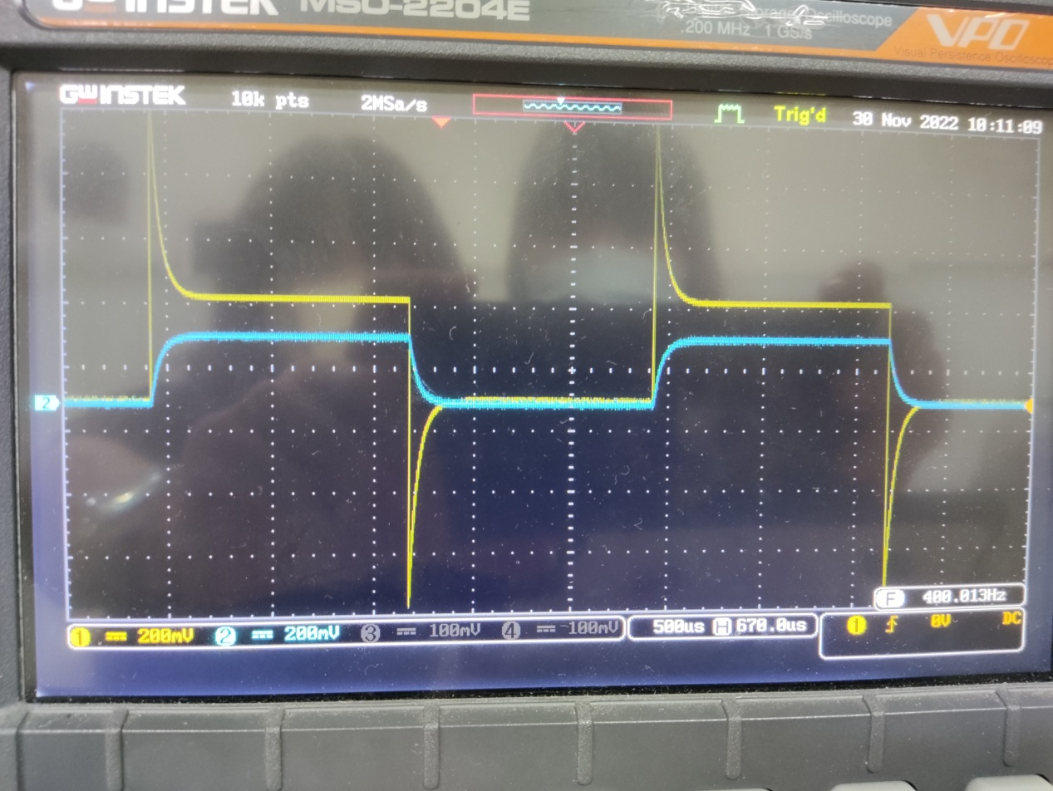

The output signal of channel 2 is the voltage curve of inductor, and the output signal of channel 1 is the voltage curve of the whole circuit. According to the result of channel 2, after 100 $μ$ s, the voltage reaches to steady state,

$0.0001÷5=0.00002\left(s\right)$ would be the time constants, which is NOT as same as the ideal $τ$.We guess the reason behind this is that there is parasitic capacitance in the inductor that interfere the output result.

* + 1. Yes, the time constants obtained during charging and discharging.

1. Reflection

B103015006 胡庭翊

Starting from this experiment, we go back and do the experiments related to circuit theory. In this experiment, we see the characteristic of capacitor and inductor. Although we had been taught of both this two circuit element and the equation behind them, moreover, even calculated their differential equation and predict their states, this is my first time observe them by oscilloscope. Capacitor is an electric element that can store voltage, its voltage will reach to steady state after 5 time constants, which can be view as a battery, moreover, the current passing it will decrease and reaches 0A in steady state, which can be view as an open circuit. On the country, inductor is a circuit element that can store current, its relationship between voltage and current is opposite to capacitor. It is cool to observe these phenomena with my own eyes, and thanks to TA and my group mate, we finished our experiment efficiently.

B103015018 劉姵妤

Through the experiment, I practically realized that capacitor and inductor have totally opposite characteristics. When power source generating positive voltage, for capacitor it present an increasing tendency to come to the maximum voltage, but for inductor it decays until it balance,

and vice versa. It feels like all of the paperwork we have done in the electric circuit courses are really demonstrated by the circuit. Just like the teachers said before, the capacitor is a kind of charging battery, and it truly does, which is verified through this experiment. It feels good and motivated to understand what I have learned before and why I learned it. Thanks to my teammate and TAs, solving and stay with me to facing on the problems I encountered during the experiment, so that the experiment could undergo so well.